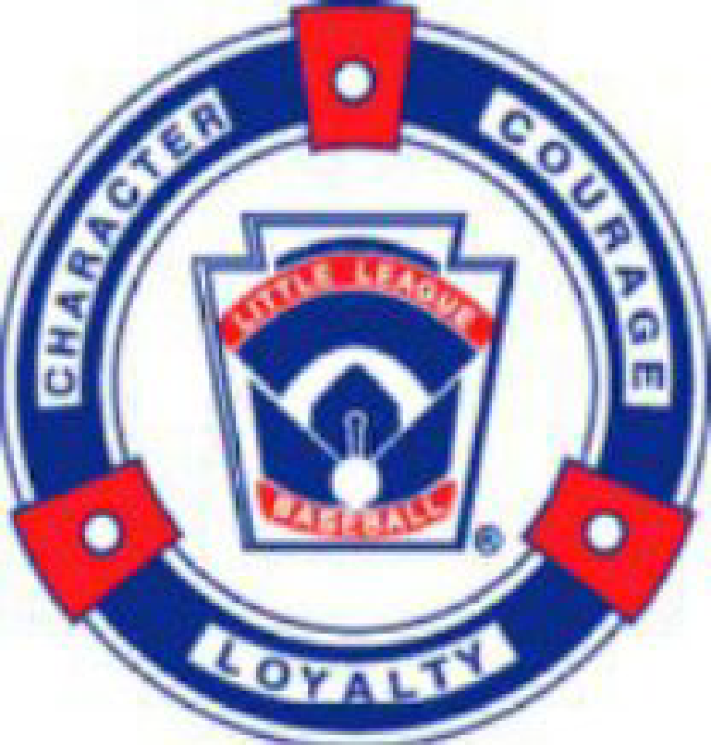

**High Plains Little League (HPLL)**

**02/17/2025 Board Meeting Minutes**

**Holtz House, Falcon, CO**

**Attendees:** Ashley Carpenter, Kevin Carpenter, Jared Holtz, April Standerfer-Holtz, Dan Carlson, Gina Klimek, Jeff Klimek, Kristina Johnson, TJ Hartley, Bobbie Lehman, Doug Ziegler

**02.17.1: Call to Order 6:05 PM**

**02.17.2: Meeting Minutes Sent via Email for approval**

* 1/27/25 meeting - 12 votes to approve - Considered Approved.
  + Approval completed online via email prior to meeting.

**02.17.3: Treasurer update (Gina):**

* Account Status-
  + 1//28/2025 $54162.15 moved to ENT from Farmers State Bank.
  + Current Farmers State Bank balance $6380.00.
  + Current balance ENT $115,951.21 as of 2/17/2025,
  + Looking at past balances to see what the lowest balance history was, the lowest ENT balance was $9,414 approximately which was when the account was opened. The lowest balance in Farmers State Bank was $45,767.70 On August 7th 2023.
* Accountant Update-
  + The accountant Becky could not make the meeting today but did send updates.
  + She is working on vendor updates in QuickBooks.
  + She is working through October 2022 thru September 2023 information. She has advised there will be some follow up for HPLL to do and that she does have questions on some transactions, she is comparing statements along the way.
  + Jared asked to have recent fiscal year done first so we can get tax exemptions. Gina agreed we need to prioritize most recent years info/taxes. Jared and Gina will speak with her to see, if possible. We will need most recent year done in order to apply for a raffle license which is needed for golf tournament, but taxes need to be done first.
  + Ashley asked if we will need to find another raffle option. Confirmed we will need a new option if we don’t have the licenses prior to the tournament.
* Current account status: Farmers and ENT
* Working Budget: Voted to approve Safety budget change to $850 by adjusting Field usage costs for FSC.
  + This was approved via email by the board prior to the meeting.

**02.17.4: Registration update (April/Krista/Kevin):**

* Registration/Coaching status/update conversation-
  + Baseball:
    - Juniors 40 with 2 waitlisted
    - Majors 72 with 1 waitlisted
    - Minors 81
    - Rookies 73 with 5 waitlisted
      * Those 5 won’t come of the waitlist if we can’t get another coach.
    - T-Ball 96 with 6 waitlisted
      * Those 6 will not come the waitlist if we can’t get another coach.
  + Softball
    - Minors 32
    - Majors 36 with 2 waitlisted
    - Juniors 2.
  + Discussed as a board allowing 13 players per team to take kids of waitlist, if we allow, we would need to purchase more hats. Board agreed to allow the waitlisted players. April activated waitlist; players families will have 48 hours to pay.
* Fundraising/Sponsorship/Scholarship Notes-
  + Kevin had meeting with Daniels fund, it was more of a meet and greet, Daniels Fund gave some programs recommendations to apply for but we need taxes done first.
  + Daniels fund point of view is building baseball field with county will be challenging. They think lights could be an option. If we attempt to build fields HPLL will gave to have capital funding. If we want their help with Lights no capital funding is needed.
  + Conversation needs to be had with El Paso County to see if they will allow/approve for lights. Jared and Kevin will arrange meeting to discuss.
* Refund Policy discussion-
  + Current Refund Policy
    - 100% refund if requested before the Draft
    - 50% refund if requested within first 2 weeks of regular season practice
    - NO refunds will be given if requested AFTER the first 2 weeks of regular season practice or games have begun
  + April proposed that the board amend and update the policy to begin applying after the 2025 Spring season.
    - Refund requests have been requested due to family issues, injuries as well as last minute decisions to move to travel ball. propose
    - Proposed adding a cancellation fee of like $25, and after tryouts 50% and after draft no refunds, as is causes HPLL a loss.
    - April will write up a proposal with verbiage to be addressed next month.
* Working on donations for Scheels gift cards to give away at our Uniform Pick up. Zero HPLL funds will be used for this giveaway.

**02.17.5: Facilities for 2025**

* Still have not heard anything on PLC Small for Softball. Follow up has continued.
  + Jared is reaching out multiple times a week until he gets a response, no confirmed reservations
    - If we do not get PLC small Bobbie can set up 2 games at WHES if needed to be able to move around softball and baseball games a little.
* Working on portable restroom quotes. Needs currently FMS, WHES, MRES, and 1 FRP. Possible need at PLC too.
  + Jared will send out quotes for approval once he gets them.
* Kevin requested that we reach out to have the lip on white field cut down by the county. Jared will schedule meeting for early March. He will coordinate with Kevin so he can be there too.

**02.17.6: Tryouts 2025 (TJ)**

* February 22nd: 8-12 and 6-9pm. Makeup Monday 2/24 Time 6-8pm. (10 that says they cannot come Saturday but can come Monday)
  + 7:30am check in) 8-9am - Minors Baseball Group 1
  + (8:30am check in) 9-10am - Minors Baseball Group 2
  + (9:30am check in) 10-10:35am - Minors Softball
  + (10am check in) 10:35-11:20am - Majors Softball
  + (10:45am check in) 11:20-12pm - Juniors Softball
  + (5:30pm check in) 6-7pm - Majors Baseball Group 1
  + (6:30pm check in) 7-8pm - Majors Baseball Group 2
  + (7:30pm check in) 8-9pm - Juniors Baseball
    - Check in 30 minutes prior to start point
  + Make ups so far 10 that says they cannot come Saturday but can come Monday
  + TJ indicated for evaluators he has no one, Ashley advises she can help with baseball side, Brett will help he just cannot help with Majors as that is his division,
  + Ashley has evaluators for softball. But needs someone to throw grounders.
    - Discussed that Doug cannot eval Majors Softball as that is his division someone will step in to keep evaluations neutral.
    - Junior SB need 2 evaluators. Jared will help. Bobbie’s mom and dad will help eval if needed. TJ asked to no help with Juniors SB due to his family trying out.
  + TJ has high schoolers to help and Juniors All Star players facilitate.
* Final Needs Discussion
  + Evaluation sheets
    - TJ can print off at work just needs to know how many to print off. Jared will get access for TJ to the registration reports tonight so he can add names to the evaluation sheets.
  + D-bats has charged HPLL $1000 to use facility for 2025 Player evaluations. This is the same amount as last year.

**02.17.7: Drafts 2025 (TJ)**

* Feb 25th, 26th, 27th Times and Location break down discussion.
  + Feb 25th - Meridian Ranch Rec Center
    - 5:30 PM Majors Baseball
    - 7 PM Minors Baseball
  + Feb 26th – Holtz’s House
    - 5:30 PM Minors Softball
    - 6:15 PM Majors Softball
    - 7 PM Juniors Softball
  + Feb 27th - Holtz’s House
    - 5:30 PM Juniors Baseball
* 6 Drafts: Minors, Majors, Juniors on both Softball and Baseball.
  + Majors and Minors Baseball will come to Jeff’s house after draft for equipment pick up on 25th. On the 27th Jeff will come to the draft to hand out equipment, For Softball Ashley will hand out.
  + T-ball and Rookies equipment pick up at time is TBD.
  + TJ will compile league evaluations for the draft.
* Draft Rule review. Will have rules to hand out on Saturday
  + Jared asked how we would like to address handling drafting coaches’ kids. As previously discussed, we can change the process so that coaches’ kids are drafted based off where they fall in their evaluations, meaning if the player is ranked top ten, he would the coaches first round pick but if the player was in the bottom ten he’d be the coaches last draft pick. This would allow those teams to get a chance to balance out skill levels.
    - Kristina agreed it would help even teams and make it a little fairer for teams just moving up in a division. Jared said it will also help the coaches new to coaching or new to HPLL. Kev feels it might hurt some teams at least from the softball side because it’s a small group of girls to pick from.
    - Proposed we try the new approach out for baseball this year,
      * Bobbie motioned to approve, Doug 2nd the motion, remaining board was all in favor to try new approach for baseball only. No one opposed
    - Coaches will need to check out after evaluations to get a copy of the draft rules.

**02.17.8: Coaches Clinic (Brett and Jackie)**

* Vibes Conference Room: Saturday March 8th 9am-12pm
* Will have Breakouts and need help. Jared will schedule follow up discussion with anyone who will have a role or need to speak at the clinic.
  + Brett has PowerPoint created to go over.
  + Jared will work with Brett regarding breakout sessions.
  + Would like as many board members as possible to attend.

**02.17.9: Volunteer Status/Update (Kristina/April)**

* Background checks, concussion, abuse, etc.
  + Majority have completed backgrounds. There are few coaches in the Minor through Majors division that have not done backgrounds yet but follow up has been sent so the know it’s needed before evaluations on the 22nd.
  + Concussion and Abuse certifications are still taking time but that is normal.

**02.17.10: Softball (Ashley)**

* Any softball updates.
  + Everything is set up for indoor practices and Ashley has worked with Jeff for the remaining equipment needs.

**02.17.11: Safety (Jackie)**

* Safety Plan Status - Ready for upload. We were waiting on email updates.
  + Need non-profit paperwork for emails to be finalized. But Doug expects emails to be ready any day now.
* Binder Plan for distribution to coaches- might need help compile binders
* First Aid Kit plan/idea/budget - Waiting for update. Ordered, no tracking yet, hoping to have in time for drafts. We can pass out as coaches’ clinic if needed.

**02.17.12:** **Scheduling/Umpires (Bobbi/Doug)**

* Status on Scheduling communication- g
  + Bobbie indicated the schedule still has room in if for Softball and Baseball make up games as needed.
  + Bobbi got all 4 local leagues working on interleague for majors and juniors baseball. Deadline for leagues to pick their interleague daes was provided as March 5th
  + For Softball, Colorado Springs are the only ones who have responded for interleague, she needs contact information for Tri-Lakes.
  + With current schedule Juniors might play 20 games, 2 games a week.
  + No interleague games will be played at the Vibes Stadium opening day now that we have Baseball Juniors teams
  + All baseball championship games are schedule for the week of June 7th.
  + All softball championship games will be on May 31st.
    - Ashley will shoot for lights for that day.
  + There will be Minimal interleague for majors baseball as of right now.
* Umpire plan/status - Contacts made (Doug)
  + 212 umpires to cover games, Dick is helping Doug create a schedule for umps and Umpire classes date TDB
    - Ashley and April have contacts for youth 14 and up that are interested in learning to umpire. Doug will to try to grow the list of umpires.
      * If they umpire is new they will be paid $30 a game price will go up to $70 a game for experiences/certified umpires.
    - $12,000 is the current calculated cost for ump plan using people we trained. The budget approve was for $17,000 so we will come in under budget if that works out.
    - Rocky Mountain Sports umpire organization will be charging $100, that cost is $85 for the umpire plus $15 schedule fee. Cost goes up to $150 for 2 umpires.
      * Budgeting for 1 umpire for Majors Baseball and 2 for Juniors Baseball.
  + Ashley suggested we use the new umps to minors division to start the program.
  + 2024 $15024.00 spent on umpires
  + Bobbie advised she proposed to the interleague that each league provide 1 ump and we provide 1 in order to have 2 for those games.

**02.17.13: Open Discussion**

* Important Date Schedule: Opening Day, Pictures, Uniform Handout
  + April 19th Opening Day at Vibes Stadium
  + April 5th uniform pick up and pictures at Vibes Stadium
* Golf Tournament: Locations Date discussion
  + Woodmoor- has to be on a Monday June 9th
  + Kings Deer- Friday June 13th.
    - Will donate 4some for prize
    - Give $10 per player for prizes
    - Traditional buffet burgers/brats, can pay up for brisket
  + $125 Woodmor per player, $130 Kings Deer per player
    - Bobbie motion to use Kings Deer on Friday June 13th. Ashley Second the Motion. One opposed date remaining board was all in favor.
    - Kings Deer Deposit is $500, non-refundable. Security deposit 14 days prior to event.
    - Bobbi motioned to approve, Ashley Second the Motion. All remaining were in favor.
      * All approved.
  + Use same website again $297 cost last year.
  + Need to discuss and invest in items for raffle, Bobbie can check if Blake from Rockies can donate something.
    - Jeff requesting from fundraising cost line item of no more than $1500.00 to make purchases of memorabilia to use for raffle/silent auction.
      * Bobbie motioned to approve for no more than $1500.00, April second the motion, all were in favor and approved.
  + Pickle ball tournament proposed by Doug to be done during off season for fundraising. He will get details and present to the board at a future meeting.
* Emails Change update
* Next Board Meeting 3/10 - Holtz House 6 pm
* Open Discussion
  + D-Bats schedule still pending for practices.
  + No games schedule 4/5 for pictures days
* April proposed that if you are removed form board or determinant to league, we should amend constitutions in some way to protect league, will look into verbiage and dismissal clause. Also suggested we add a vision and value statements as well. More to come at future meeting.
* Mike Sedillos passed on Feb 6th. Jared would like to do something to remember Mike at opening ceremonies and during All Stars, Jeff motioned to donate to his celebration of life with money or flowers, Jared will look into and follow up with email to vote.
* For additional spots in Junior’s baseball April said we can try to get some aged-out juniors to come back they just cannot pitch and cannot play all stars. Need at least 2 more players. TJ can reach out to the ones he knows.
* Board encouraged to watch the upcoming KRDO news cast to air at 6pm on Feb 18th. We are unaware of what the story will be but we know it involves Academy and Little League as a whole.
  + Jared said no response to news story will be sent out without board approval first.